Week 8 (Lab 8) LESSON PLAN LB144 Fall 2024

Prep: Prepare a 10% Chelex stock solution (in H20) place in the refridgerator.Setup and turn on water(50C) and sand (95FC) baths. Get glassware/supplies for DNA extraction from Saliva with Chelex, and making gels. Prep slides on compute. Open the Attendance & BUMP point sheet.

---> Bring your three graded Half-Draft papers for Luckie.

1. ATTENDANCE (learn names) - LA1 (e.g. turns out "Ana" is pronounced "Ah nah")
O Take attendance– eventually, work on also using last names and thus learning how to pronounce them too

ANNOUNCEMENTS -LA2 talks LA1 writes on whiteboard
BUMP points reminder, buy Primers ASAP, write researchers for animal DNA samples, view movies on D2L about making gels and performing PCR as a resource. Prof Interviews begin, Exam II take-home begins.

---- Let's all spit in tubes and get human genome with Chelex now LA2

Talk: How to use Chelex to isolate/purify human genome from cheek cells, What health & safety steps should be used (gloves, eye protection, clean-up and waste), How do you analyze the results to determine if Genome Prep worked?

Provide one handout to each group with Chelex protocols outlined.

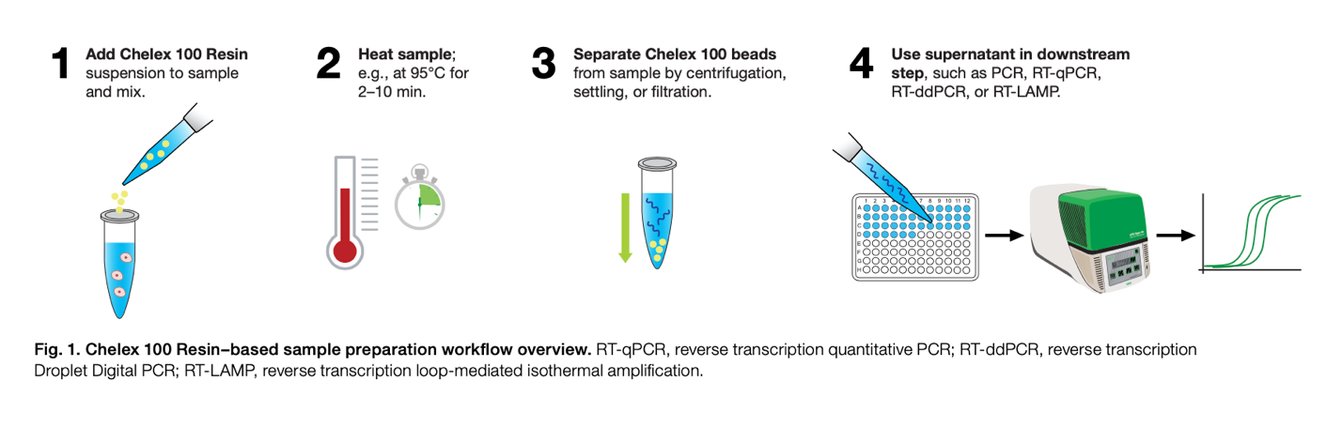

TIP: Have one part of your group make a gel and the other create a protocol for Chelex in Chalk on benchtop.

After Chelex prep and put sample in gel to run it and use Nano Drop to check absorbance.

---- (during Chelex & final 30 minutes)

DEPARTURE CHECKLIST (With 10-15 minutes remaining start these)
  - Make sure students clean up their lab areas.
  - BUMP points time

