Week 7 (Lab 7) LESSON PLAN LB144 Fall 2024
Prep: Half-Draft will be turned in prior to entering room, get glassware for making agarose gels (little beakers, 250ml Erlenmeyer flasks, graduated cylinders, "20X" LB buffer, agarose powder, balances, weigh boats, turn ON projector get computer working well with projector, get "Make Gel" slides ready. Clean benches.

-- Have students submit Half-Draft papers on cart before entering room (groups who choose to delay can do so). At end of lab return papers that need fixing.

1. ATTENDANCE (learn names) - LA1
O Take attendance– eventually work on also using last names and thus learning how to pronounce them too

ANNOUNCEMENTS -LA2 talks LA1 writes on whiteboard (then switch places half way through).
-Documentary Film option: Announce “If you want this to be the last paper you write for the course, you can create a documentary film instead". Show video(?) of prior student movie (is on D2L).
BUMP points reminder, Buy Primers ASAP, View movies on D2L about making gels as a resource.

-(Optional) the 4.0-level research is only required for those who seek a 4.0. If you are targeting a different grade level as your course grade you may OPT out of the molecular PCR experiments and have time during each lab period to do observations much as we have done earlier in the course for an hour or more in the middle of lab.

-(Optional) BONUS: If you provide a detailed explanation of how you did revisions, how feedback on the first paper led to your changes in the second paper, you can increase your final grade by a full grade level (essay or movie to luckie by 5 PM Friday)

-Note: next week is exam week and the week after is fall break, what is due before fall break? When Geese gone?

-Next week's exam week, so Monday is used for the exam so there is no "lab meeting" on Monday.

-BUMP points are a big gift. Please continue to fully participate and get them throughout the entire semester to substantially raise your grade and lower your stress, but please check the rules provided in the "discussion forum" on top hat. You will need a notebook that is holding all your papers, and your method section in your full write up in your notebook has to be more than quick dashes of bits of information.

-If you are one of the dozen people who have not done any or many BUMP points, please consider it, and please let us know if you need help with something to make doing observations that work well for you.

-Groups who forget to follow the instructions authors will just have their papers returned back to them at the end of the lab today. Remember late points and rejection points with apply, a hardcopy of the paper as well as a digital copy uploaded to turitin.com were both due at the start lab today.

-The "prof interview" as well as the "verbal status reports" can start immediately for anyone who would like to get them out of the way instead of waiting/procrastinating. email Luckie if you'd like to and when. After fall break, people will begin being assigned for times for both. These will be done each week for many weeks.

-Anybody who still has questions about this weeks exercise done during our Monday "lab meeting" when you worked through the integrated questions about insulin using the software and NCBI. We are happy to talk to any of you about this. If it didn't quite work or it didn't quite make sense. And your curious. Let us know.

-Begin to bring lab coats and goggles for the rest of the semester in lab, now it is a wet lab, ALSO hazardous waste is critically important. Put gloves in the gloves waste, gels only in the gel waste paper towels in regular trash. Be careful WHERE you place your experimental waste. If you put something in the wrong place we will ask you to fix it before you can leave.

End of announcements

---------Pipets training (may take up to 30 minutes) -LA1 leads the first part for the full class
(can use document projector to show pipet window or close up of things)
  - Have everyone pick up a pipet, tip, perhaps rack with Eppendorf tubes and water in each.
  - Explain to entire class how to read window with volume setting
  - Explain to whole class how to pipet and what the feeling is depressing the plunger to the first point of resistance and then beyond, what those points are and mean.
  - Then each LA goes to a group and works with them. Quiz them, “here’s this pipet, what volume is a set on?” etc
  - ONCE a group is approved to have been trained they can move on to Making Gels.

---------Let's do Making Gels Exercise now “Making gels” exercise -"Make a Gel" slide then do it in lab (30-60 minutes) DO NOT REVEAL FINAL SLIDE - LA2

(during this period somebody checks submitted papers for accept or reject)

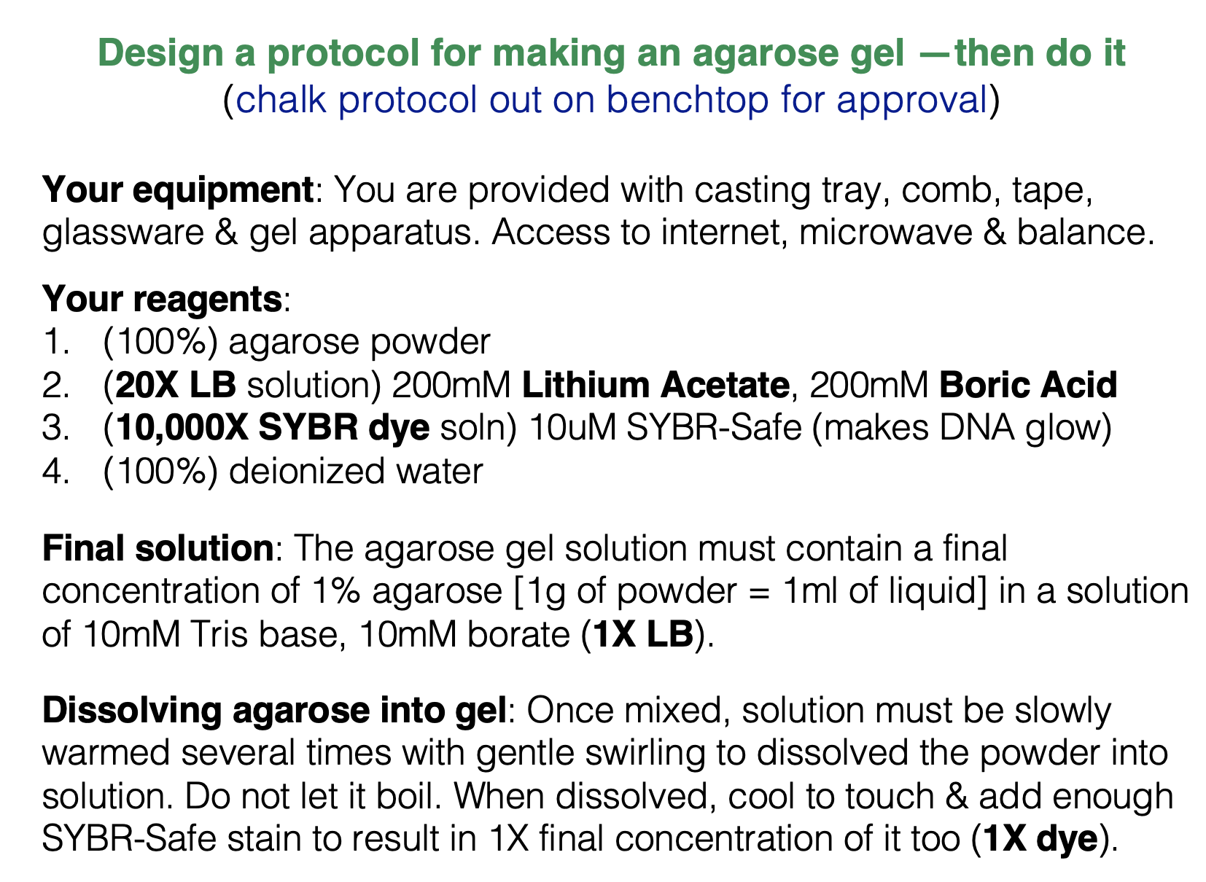

---- If time permits, can practice loading gel wells with loading dye and even run the gel to see what happens

DEPARTURE CHECKLIST (With 10+ minutes remaining start these)
  - Make sure students clean up their lab areas. Check waste containers.
  - end of lab return papers, place back on Cart in hallway, that need fixing
  - BUMP points once the student's bench area is cleaned completely

